

ROTARY OIL VACUUM PUMP

VPBDR
User Manual

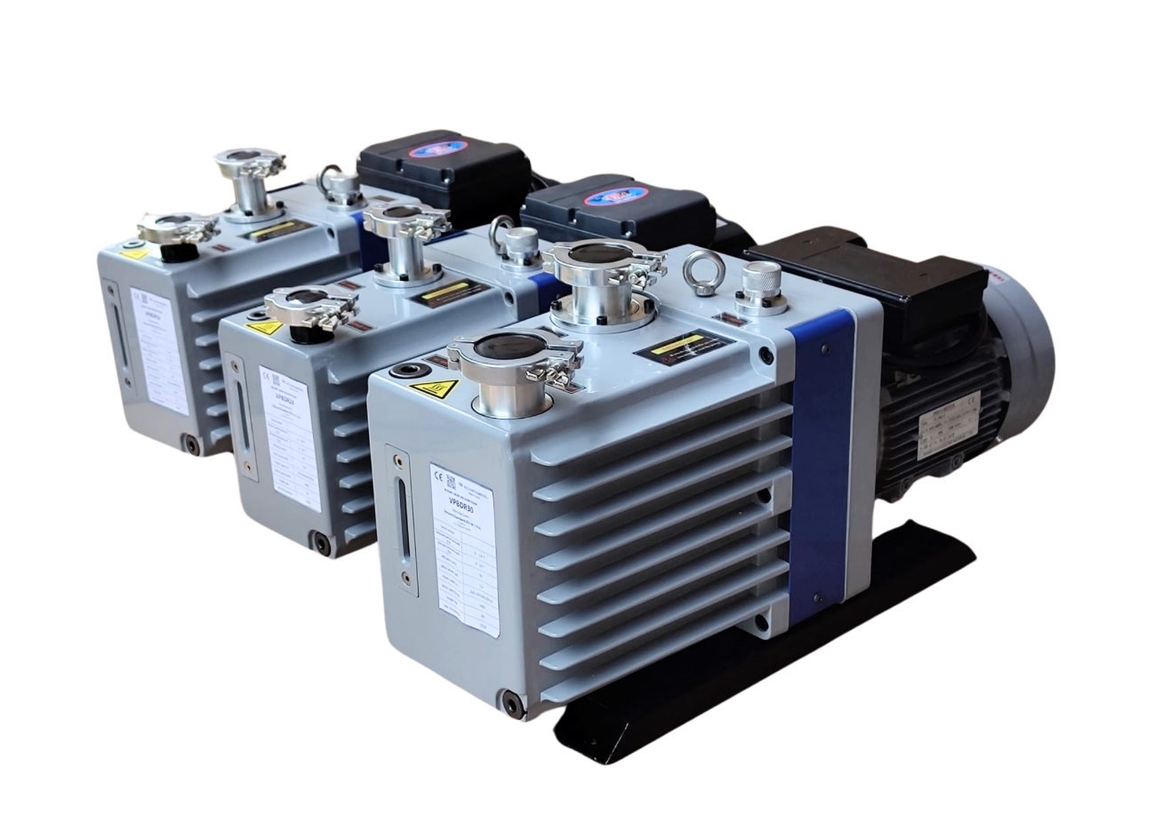
Model: VPBDR16, VPBDR24, VPBDR30.
TRANSLATION OF THE ORIGINAL USER MANUAL

Distributor:

VacuumChambers.eu Sp. z o.o.
Ul. Augustowska 6/1/1
15-218 Białystok
NIP 5423479018

Poland

E-mail: shop@vacuumchambers.eu; Tel.: +48535312207
All photos used in this manual are illustrative photos. The appearance and quantity of the elements supplied to the customer, as well as their mutual location may vary depending on the ordered vacuum pump.
This user manual is based on current knowledge and experience. The distributor reserves the right to change the content of this manual without informing the consumer.

ENVIRONMENTAL INFORMATION:

Do not dispose of that product as unsorted municipal waste.
Used equipment should be sent to an electro-waste collection point.


Nature friendly company.


SYMBOLS USED IN THE MANUAL:

Danger - A hazard that can cause injury or damage.



Hot surfaces. Risk of burns.



Danger - Electrically energized device.



Necessity to read the instruction manual of the device.



Necessity to use eye protection.



Necessity to use appropriate protective gloves.



Necessity to use protective clothing.

BEFORE USING, PLEASE READ THIS USER MANUAL. Keep the manual for possible future use, as it may always be necessary to remember the information contained in the manual, and it must be provided with the device in the event of reselling the machine or changing the user.


WARNING! In order to avoid the risk of injuries and accidents, as well as to increase work efficiency and prevent premature wear of the device, read all warnings, safety instructions and paragraphs marked with the symbol: .

Contents
1. WARNING! Safety Instructions.. 4
2. Range of applications 4
3. Properties of the rotary oil vacuum pump . 5
4. Preparing a rotary oil vacuum pump VPBDR for operation . 6
A. Instructions for first use . 6
5. Operating Manual 7
6. Notes about use 7
7. Optional additional equipment 8
8. Trouble shooting guide.. 9
9. Maintenance . 11
A. Oil for rotary oil vacuum pumps 11
B. Oil change. 11
10. Parts list. 13
11. Warranty. 14
12. Declaration of conformity 14

- WARNING! Safety Instructions.

- During work, use personal protective equipment, including: protective goggles, protective gloves, clothing and footwear.

- Some parts of the vacuum pump get very hot during operation. To prevent burns, never touch the body and pump motor. Be careful when changing hot oil.

- The general rules for the use of equipment working under voltage must be observed.

- Perform servicing and maintenance of the vacuum pump periodically.

- Before each use of the vacuum pump, it is necessary to check its technical condition, in particular the supply cable.

- Be sure to use product in safe, well-ventilated area, on flat, stable surface.

- Avoid excessive pollution of the working environment by dust, powders, small solids or water, as heavy contamination can damage the pump.

- The user must ensure that the chemicals used by him in the intended process or when cleaning the device do not damage the elements of the vacuum pump.

- The pump is not suitable for pumping excessively oxidised, poisonous, explosive and corrosive gases, as well as gases that react chemically with the pump oil or contain dust particles.
- Pumps available in the standard VacuumChamber.eu offer are not intrinsically safe.

- The customer is solely responsible for the appropriate selection of the vacuum pump for the intended purposes and technology.

- Do not assemble or disassemble individual parts of the vacuum pump or the components of the vacuum set connected to it, while the vacuum pump is operating.

- Never put fingers or other objects inside the pump rotor cover. Keep your hair, clothing, gloves and other objects that could get into the rotor away from moving parts.

- Do not expose the device to rain or excessive moisture.

- Do not leave the vacuum pump unattended during operation.

- Do not subject any parts of the human body to under pressure.

- Keep children, people with disabilities and animals away from the operating area of the device.

- Be foreseeable, watch what you are doing, and be reasonable when using the device. Do not use the device when you are tired or under the influence of drugs, alcohol or medication.

- The device should be operated by trained technicians, mentally and physically able to operate the vacuum pump and its individual components.

- Vacuum pump is intended for professional use. It is not intended for non-professional use. The buyer is obligated to secure the vacuum pump and all its components against unauthorized use.

- Do not use the device or any of its parts for purposes other than those for which it was intended. Do not make any modifications or changes to the vacuum pump or its individual components. Any modifications or changes are made by the customer under his sole responsibility and will void the warranty.

Range of applications.

Rotary oil vacuum pumps offered by VacuumChambers.eu are characterized by high efficiency, very high value of the achieved vacuum, easy startup and quiet operation. In addition, they are characterized by a favourable price-quality ratio and are covered by a one-year warranty.

Vacuum pumps are used as a component of vacuum sets for degassing moulding compounds and other products such as silicone, resin and gypsum. They can be used in the impregnation of wood and other porous materials.

The vacuum pump should be operated in the following conditions: ambient temperature from + 5 ° C to + 40 ° C, inlet pressure below 1230 Pa, air humidity up to 90%.

Properties of the rotary oil vacuum pump.

1
2
3
4
5

Rotary oil pump VPBDR (Photo 1) consists of:
6
7
8
9
10
11
12

`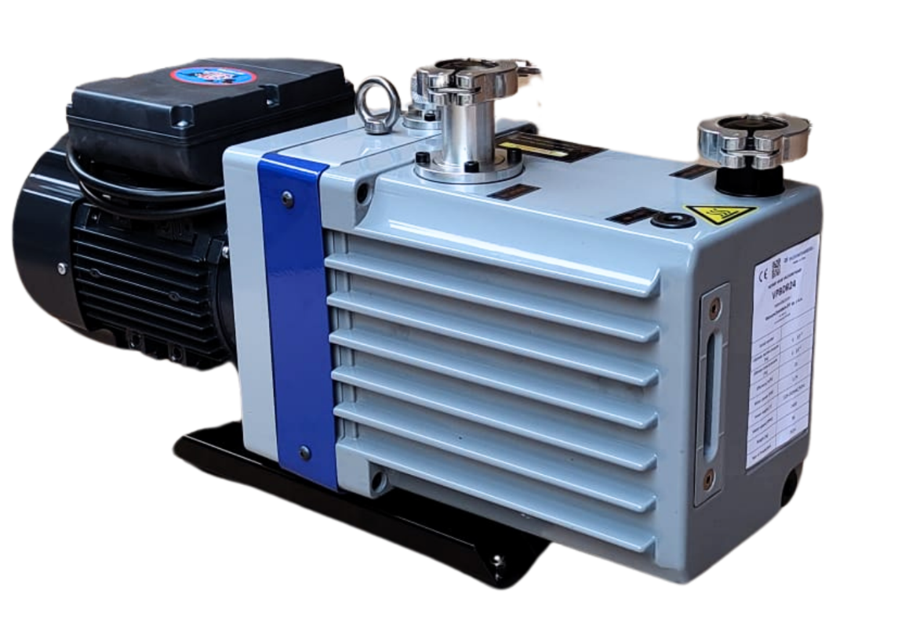
Photo 1: Vacuum pump VPBDR series.
- Gas ballast.
- Fan cover.
- Motor.
- Oil box.
- Base.
- Air inlet.
- Air outlet.
- Oil inlet.
- Nameplate.
- Oil sight glass with minimum and maximum oil level mark.
- Oil drain.

Vacuum pumps of the VPBDR series have an electric motor (3), the fan of which is shielded by a cover (2). Connected to the motor housing is an oil box (4), which contains the components that allow the pump to generate vacuum. On top of the oil box are an air inlet (6), an air outlet (7), and an oil inlet (8). The connection port size for the VPBDR16 and VPBDR24 pumps is KF25, for the VPBDR30 pump it is KF40. An oil filler and oil drain are unscrewed and screwed on using a size 8 Allen key. A vacuum set line must be connected to the air inlet, while an oil mist filter available from VacuumChambers.eu can be fitted to the air outlet. On the side of the oil box you can see a nameplate (9), an oil level sight glass (10) and an oil drain (11). The model of the vacuum pump is marked on the nameplate. The oil level visible through the sight glass should be between the convex lines indicating the minimum and maximum permissible oil level. Oil can be added via the oil inlet, while old oil or excess oil can be removed by opening the oil drain. Exact instructions for refilling, pouring and changing the oil can be found later in this manual. The pump is positioned on the base (5).
Vacuum pumps in the VPBDR series are equipped with a gas ballast valve (1). It allows the pump outlet space to be opened and filled with a certain amount of air. This makes it possible to purge the oil from the vapours escaping during the vacuuming process. However, it must be remembered that opening the ballast valve reduces the pump's ultimate vacuum value and increases the pump's temperature.
Rotary oil vacuum pumps achieve an ultimate vacuum of 0.0006 mbar (0.06 Pa) of absolute pressure. Table 1 shows the properties of the VPBDR series of vacuum pumps.
Table 1: Properties of vacuum pump VPBDR series.
Pump model: | VPBDR16 | VP BDR24 | VPBDR30
Pump speed (m³/h): | 16 | 24 | 30
Partial vacuum (Pa): | 6x10⁻² | 6x10⁻² | 6x10⁻²
Ultimate vacuum (Pa): | 6x10⁻¹ | 6x10⁻¹ | 6x10⁻¹
Rotary speed (r/min): | 1400 | 1400 | 1400
Motor power (kW): | 0,55 | 0,75 | 1,5
Working voltage (V): | 220V/50Hz | 220V/50Hz | 220V/50Hz
Inlet/Outlet: | KF-25 | KF-25 | KF-40
Quantity of oil (L): | 1,4 | 1,5 | 2,5
Dimensions (mm):  (length x width x height) | 520x172x285 | 545x172x285 | 650x240x430
Weight gross (kg): | 33 | 36 | 60

Preparing a vacuum pump VPBDR for operation.
During transport, there is a risk of oil spilling from the pump. The pump delivered to the customer is therefore fitted with plugged inlet and outlet ports. The customer should prepare the pump for operation himself in accordance with the instructions below. Do not start the pump without oil, as this may damage it.
- Check the oil level before using the pump.

- Always remember to open the pump air outlet !!!

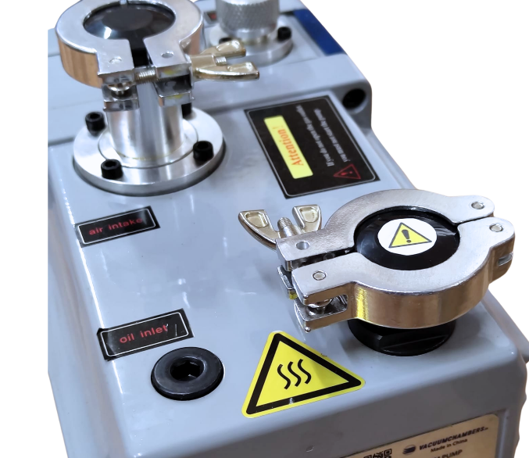

Open the outlet port before operation

Photo 2: VPBDR pump air outlet.

- Instructions for first use.
- Position the pump on a flat, horizontal surface

- Check the oil level by checking the amount of oil on the sight glass. The oil level should be between the limiting oil level marks, preferably in the middle. Too little oil in the pump can result in poor performance or damage to the pump. Conversely, too much oil can result in oil blowing out at the air outlet.

- Switch on the pump (with the outlet port open) and let it run for 1-2 minutes.
- Check the oil level - it should be between the limiting oil level marks, preferably in the middle.
If necessary, refill the pump with oil or pour off the excess oil.
To drain excess oil from the pump:
  - Place a container under the oil drain.
  - Open the oil drain and pour the excess oil into a container. (When unscrewing the oil screw, be careful not to lose the O-ring sealing the oil drain.
  - Switch on the pump and let it run for 1-2 minutes.
  - Check the oil level again.
- The pump is ready to use.

Operating manual.
It is recommended that a vacuum pump VPBDR be combined with a vacuum system equipped with an air valve located between the vacuum system and the pump. Such a valve should make it possible to cut off the vacuum pump from the vacuum generated in the system. The following operating manual describes what to do when using a vacuum pump VPBDR with a system equipped with the air valve. If your vacuum set is not equipped with the air valve described, ignore the notes in parentheses in a paragraph ”5. Operating manual.”.


Do not operate the vacuum pump if its outlet port is plugged – Photo 2

- Position the pump on a flat, horizontal surface.

- Connect the pump with which vacuum system is to work:

(The valve between the system and the pump should be closed.) The hose of the vacuum system should be tightly connected to the air inlet of the pump.

- Connect the pump to the power supply (the air outlet of the vacuum pump must be open).

- (Open the valve between the vacuum system and the pump.)

- Carry out the intended process.
- Switch off the vacuum pump.
(It is recommended to close the valve between the vacuum system and the vacuum pump before switching off the vacuum pump).
- You can disconnect the vacuum system line from the air inlet of the pump. Be sure to protect the pump air inlet from contamination

- .
- Notes about use.
- Before starting work, ensure that the oil level in the pump is correct. The pump must not be operated with no oil (possible damage to the pump), too little oil (reduced pump performance) or too much oil (possible oil spillage at the pump outlet).
- The vacuum pump must always be set below the vacuum tank.
- It is recommended to combine the pump with a vacuum system equipped with an outlet air valve. Such a valve should allow the vacuum pump to be cut off from the vacuum generated in the system. This prolongs the life of the pump and facilitates startup.
- When using a vacuum pump from the VPBDR series in vacuum sets to carry out processes that cause heavy oil contamination, such as wood stabilisation, it is recommended that the oil be decanted after each process. The decanted oil can be reused as long as it has returned to its original properties. During the process, the gas ballast valve can be opened to allow the oil to be purged of vapour. Failure to comply with this point may result in corrosion and accelerated wear of the pump mechanisms.
- In order to protect the vacuum pump from certain harmful compounds (e.g. water, ethanol), a vacuum cold trap, available from VacuumChambers.eu, can be used.
- The air inlet of the pump should always be secured with a cap or connected to the vacuum system hose. Leaving the air inlet open can result in contamination inside the pump. This can reduce its performance and cause damage.
- Due to their reinforced design, the VPBDR pumps are suitable for intermittent operation in the full pressure range or continuous operation in the pressure range from 1mbar to 600mbar..

- Pumping of vapour :
- Vapour can only be pumped out with the pump warmed up and with the purge valve open – gas ballast. By purging with air at the start of the compression phase, condensation is prevented in the pump.
At the end of the process, cut off the inlet and leave the gas ballast pump running for another 30 minutes to remove any residual water from the oil. NOTE: The gas ballast valve is used to provide additional air to prevent condensation and dissolution in the oil when pumping the vapour.
- Unnecessary operation of the pump on an open purge valve (gas ballast) increases its operating temperature significantly, leading to faster wear of the vacuum pump components.
- It is recommended to store the pump at room temperature. If the pump is stored at lower temperatures, it is advisable to move the pump to a warm room before starting it up, which will allow the cold oil to warm up to room temperature. This prevents possible problems with starting the pump.
- Optional additional equipment.
- Oil mist filter.

An outlet air filter is available for the VPBDR series pumps from VacuumChambers.eu. It allows the exhaust air from the pump to be purified and thus protects the pump's working area from contamination by oil mist. The filter should be installed according to the arrow marking on the filter housing. See photo No. 3. The connection size for VPBDR16 and VPBDR24 is KF25, for VPBDR30 it is KF40.
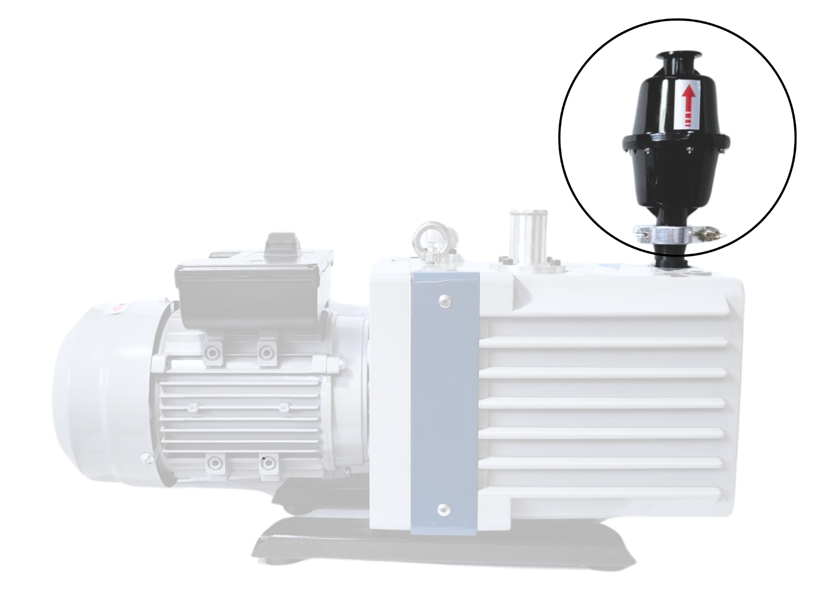

Oil mist filter

Photo 3: Oil mist filter.

- Trouble shooting guide.
Possible and the most common failures and problems are described below, as well as recommended procedure in case of their occurrence.
Problem | Possible cause | Recommended procedure
Vacuum pump does not start. | No connection to the power supply. | Check connection to power supply.
Vacuum pump does not start. | Low temperature storage of the pump which causes the oil to thicken. | Leave the pump at room temperature and wait for the pump and oil to warm up. Try to start the pump again. Do not store the pump at low temperatures.
Loud, unusual vacuum pump operation. | Vacuum pump oil level too low (which prevents the pump from sealing). | Check the oil level in the pump. Refill the oil by following section 9.B. ‘’Oil change.‘’ of this manual.
Loud, unusual vacuum pump operation. | Oil level is too high. | Check the oil level. Drain excess oil from the pump, follow section 9.B. ‘‘Oil change.’’
Loud, unusual vacuum pump operation. | Damage to the pump (including: broken vanes, bearing wear, deterioration of parts). | Stop using the pump. Contact the supplier to assess possible damage, obtain additional information or carry out warranty or post-warranty repairs.
Failure to achieve the values of the negative pressure in the vacuum chamber declared by the manufacturer. | Vacuum pump oil level too low  (which prevents the pump from sealing). | Check the oil level in the pump. Refill the oil by following section 9.B. ‘‘Oil change.’’ of this manual.
 | Oil contaminated with condensing vapour. | Open the ballast valve wide to purge the oil from the escaping vapours. If necessary, replace the oil with new oil by following section 9.B. ‘’Oil change.’’ of this manual.
 | Poor oil quality (oil contaminated or unsuitable for vacuum pumps). | Make sure that the oil used in the pump is suitable for vacuum pumps. Check the quality and colour of the oil in the vacuum pump. If the oil is contaminated or there are doubts about its quality, change the oil by following section 9.B. ‘‘Oil change.’’ of these instructions. A heavily contaminated pump may require several oil changes.
 | Clogging of oil holes. | Drain the oil, remove the oil box, clean the oil holes. Then install the oil box and pour the correct amount of oil into the pump. When draining and filling the oil, follow section 9.B. ‘’Oil change.’’
 | Pump is overheated. | Improve ventilation at the pump site, using cooling if necessary.  If the temperature of the pumped gas is too high, cool it down before the pump inlet, e.g. by extending the pipe leading to the pump and using cooling.
 | Wear or damage to the pump or its components. | Contact the supplier for further information or to carry out warranty or post-warranty repairs.
 | Weakening or damaging of the pump components by using harmful compounds in the degassing process. | Stop using the pump. Contact the supplier for further information or to carry out warranty or post-warranty repairs.
 | Misplacement or deterioration of the rubber gaskets of the inlet pipe or ballast valve. | Readjust the seals of the inlet pipe or ballast valve. If necessary, contact the supplier to replace the rubber gaskets.
 | Leakage on one or more components of the vacuum set. | Make sure that the vacuometer and all connections in the vacuum set are in good condition and tight.
Visible damage to the pump or its components.  Deterioration of the performance of the vacuum pump. | Incorrect operation of the vacuum pump. | Stop using the vacuum pump. Contact the supplier to replace the damaged components with new ones if possible. You should also inform the supplier of the manner in which the set or its components were damaged, in order to obtain additional information and advice that may reduce the risk of similar damage occurring in the future.
 | Use of unsuitable materials when using or cleaning the pump or the components of vacuum set. | Stop using the vacuum pump. Verify the safety of the substances used for degassing and cleaning the vacuum set, its components and the vacuum pump. Contact the supplier to replace damaged components with new ones or ones more suitable for the process being carried out and to obtain additional information.
Oil splashing during pump operation. | Oil level is too high. | Check the oil level in the pump. If the oil level is too high, drain some of the oil from the pump. For instructions on draining the oil from the pump, refer to section 9.B. ‘’Oil change.’’
Oil splashing during pump operation. | Clogging of oil separator. Oil baffle not correctly fitted. | Stop using the pump. Contact the supplier for further information or to carry out warranty or post-warranty repairs.
Oil leak. | Oil plug, sight glass, or oil case gasket leakage. | Check the tightness and proper installation of the oil plug, sight glass, and oil case gasket. If necessary, contact the supplier to replace any leaking components.
Oil leak. | Internal leakage in the pump. | Contact the supplier for further information or to carry out warranty or post-warranty repairs.
Oil backflow.  (The oil level drops rapidly when the pump stops). | Oil check valve leak. | Check for oil level fluctuations by starting and stopping the pump repeatedly. Contact the supplier for further information or to carry out warranty or post-warranty repairs.
 | Misplaced or damaged oil gaskets inside the pump.  Worn outlet valve plate. | Contact the supplier for further information or to carry out warranty or post-warranty repairs.

If the above information did not allow to fix the problem or the problem that occurred is not described above, please contact the supplier for additional information or to return the product for warranty repair or post-warranty service.

- Maintenance.
Vacuum pump must be kept clean and the pneumatic components must be taken care of, so that the extraneous objects don’t get into them and as a result block and damage the pump. Do not clean the vacuum pump with flammable liquids, solvents or by spraying it with a stream of water. The pump housing can be cleaned with a damp cloth using a mild detergent or a jet of compressed air.

- Oil for rotary oil vacuum pumps.
The quality and condition of the oil used in the pump directly affects the value of the ultimate vacuum achieved. Only oils designed to work with pumps that produce a high vacuum should be used in rotary oil vacuum pumps. It is advisable to use only the oil recommended by VacuumChambers.eu (Photo 4). Shell brand oil available in the VacuumChambers.eu offer is suitable for use in high vacuum pumps.

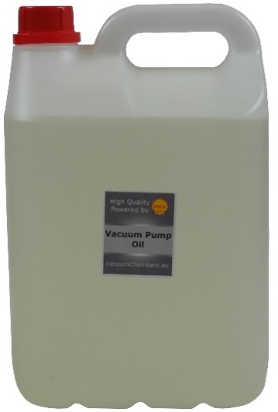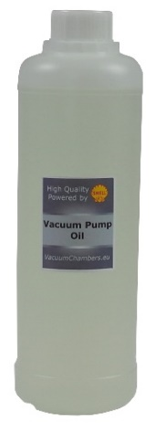
Photo 4: Oil for rotary oil vacuum pumps of VPBDR series.
It is an oil intended for use in rotary vacuum pumps that achieve a high vacuum level (not lower than 0.001 [mbar] at 65°C). The formulation of this oil consists of high-quality, selected fractions of deeply refined mineral oil. Such composition gives low oil vapour pressure and excellent lubricating properties in rotary vacuum pumps. This oil shows excellent resistance to chemical and mechanical degradation, which ensures long drain intervals and a significant reduction in the formation of deposits and sludge. It protects very well internal metal surfaces of devices against corrosion and wear. The oil can operate in a wide temperature range, from 0°C to 100°C, but the maximum vacuum level will decrease dramatically with increasing temperature. The oil is not recommended for use in conditions where corrosive gases or vapours may be generated.

- Oil change.
Oil in rotary vacuum pumps of VPBDR series should be changed every 50 operating hours and at least once a year. Also, failure to reach the maximum vacuum value, oil turbidity or a change in its colour to dark are an indication of the need to change the oil. Used oil must be completely drained from the pump and replaced with new oil.
Oil change should only be performed when the pump is warm. Be especially careful when working with hot oil. Before changing the oil, prepare a sufficiently large container for the old oil and a sufficient quantity of the new oil. The oil capacity of rotary vacuum pumps of VPBDR series varies depending on the model. To change the oil:
- Place the pump on a flat, level surface

- Allow the pump to run for at least half an hour to reduce oil viscosity.
- Stop the pump.
- Place the container below the oil drain.
- Carefully unscrew the oil drain screw with an Allen key. Be careful not to lose the O-ring sealing the oil drain.
- Allow the oil to drain freely into the container.

- When the oil stops draining, the pump should be started and work for 1-2 minutes with the pump's air inlet open. While doing this, slowly pour a small amount of clean oil into the pump through the inlet port. This will remove any residual old oil present in the pump housing.

- After draining the old oil, secure the oil drain.

The drain securing screw with the O-ring on it should be screwed back in the oil drain and tightened. The screw must not be tightened too much to avoid the O-ring damage. The entire O-ring should be seated completely in the recess of the pump's aluminium housing. O-ring protruding outside the housing causes oil leakage.
- Gradually pour oil through the oil filler hole, constantly checking the oil amount in the sight glass. The oil level should be between the limiting oil level marks, preferably in the middle.

- Close the oil filler hole.

- Let the pump run for about 1 minute.
- Check the oil level. Add oil or pour off the excess oil if necessary.
Too little oil in the pump may result in poor pump performance. Conversely, too much oil may cause blowing out the oil at the air outlet.
- Make sure the oil drain is tightly closed and not leaking.
Correct the drain oil closure if necessary. If the oil drain securing screw isn’t tightened enough, the oil may leak. In this case, tighten the screw gently, ensure that the O-ring is set correctly. Over-tightening the screw can damage the sealing O-ring.
- Dispose of used oil in accordance with local regulations.

- Parts list.
Figure 1 and Table 2 show the list of parts comprising the pump.
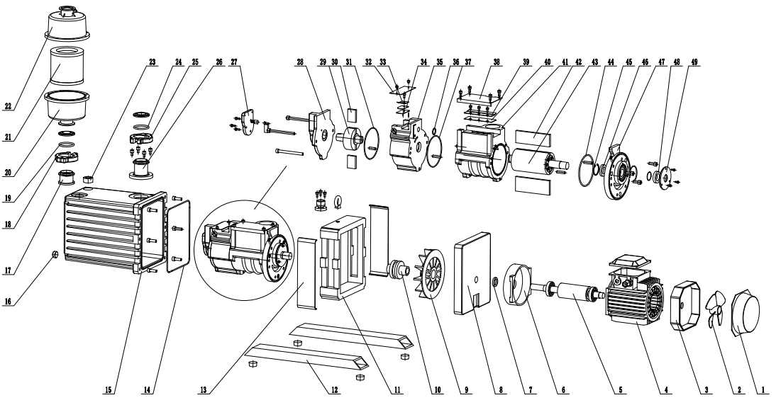
Figure 1: Parts list.
Number | Name | Number | Name
1 | Fan cover | 26 | Air inlet connector
2 | Electric motor fan | 27 | Shaft cover
3 | Electric motor cover | 28 | Stator cover
4 | Electric motor stator | 29 | Rotor
5 | Electric motor rotor | 30 | Rotary vanes
6 | Electric motor cover | 31 | Gasket
7 | Sealing O-ring | 32 | Oil baffle
8 | Connection plate | 33 | Baffle cover
9 | Fan | 34 | Air outlet cover
10 | Coupling | 35 | Stator housing
11 | Coupling housing | 36 | Sealing O-ring
12 | Base | 37 | Gasket
13 | Coupling cover | 38 | Oil baffle
14 | Oil tank gasket | 39 | Baffle cover
15 | Oil tank housing | 40 | Air inlet
16 | Oil drain screw | 41 | Stator
17 | Air outlet connection | 42 | Rotor vane
18 | Clamp (KF25 for VPBDR16/24  KF40 for VPBDR30) | 43 | Rotor shaft
19 | Centering O-ring | 44 | Sealing O-ring
20 | Filter housing (lower part) – additional equipment | 45 | Safety ring
21 | Filter insert - additional equipment | 46 | Shaft seal
22 | Filter housing (upper part) – additional equipment | 47 | Stator cover
23 | Oil filler cap | 48 | Shaft seal
24 | Centering O-ring | 49 | Cover
25 | Clamp (KF25 for VPBDR16/24  KF40 for VPBDR30)
Table 2: Parts list.
- Warranty.
VacuumChambers.eu guarantees that the vacuum pump will be operational and free of defects for a period of 12 months from the date of purchase. In the event of a breakdown during this period, VacuumChambers.eu will repair or replace any damaged system element on the terms described in the warranty card included in the set.
This limited warranty does not cover damage to the pump caused by improper use, maintenance or use not in accordance with this manual. Any use of the device which is not in accordance with the intended purpose given above is forbidden and will void the warranty and the manufacturer's liability for any resulting damage. Any modifications of the device made by the user release the manufacturer from liability for damage and damage caused to the user and the environment. Proper use of the device also applies to maintenance, storage, transport and repair.
VacuumChambers.eu is not liable for damages, nor does it cover them under the warranty, for any kind of losses resulting from the breakdown of this product. In the case of a claim, VacuumChambers.eu's sole responsibility is to accept a return or exchange of the product itself

.

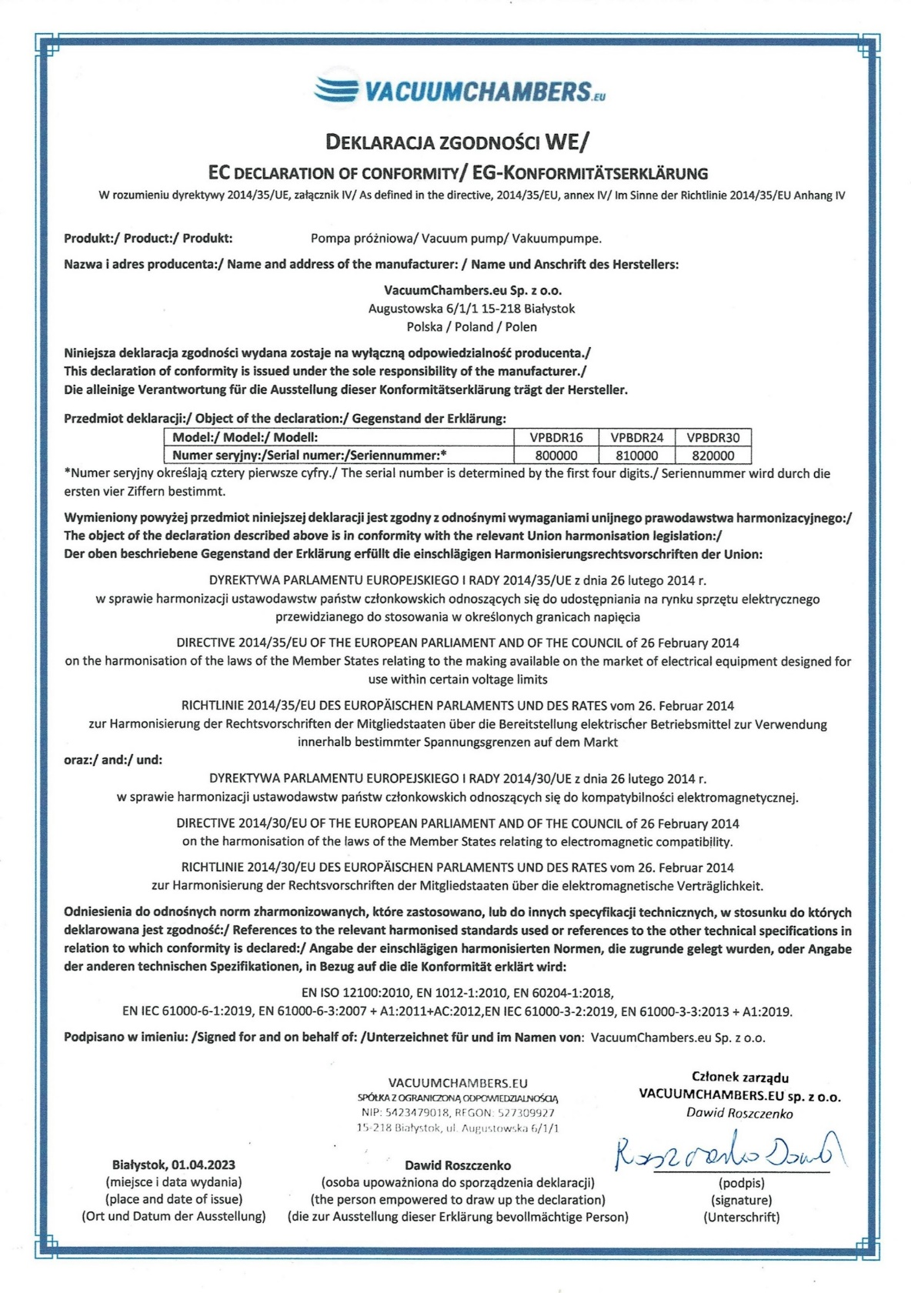
- Declaration of conformity.

